Upgrade Mobile apk 1.0 to 2.0

Current Structure for 1.0 Current Structure for 2.0

(For Example: com.selfservit.powerhub) (For Example: com.selfservit.liugongcare)

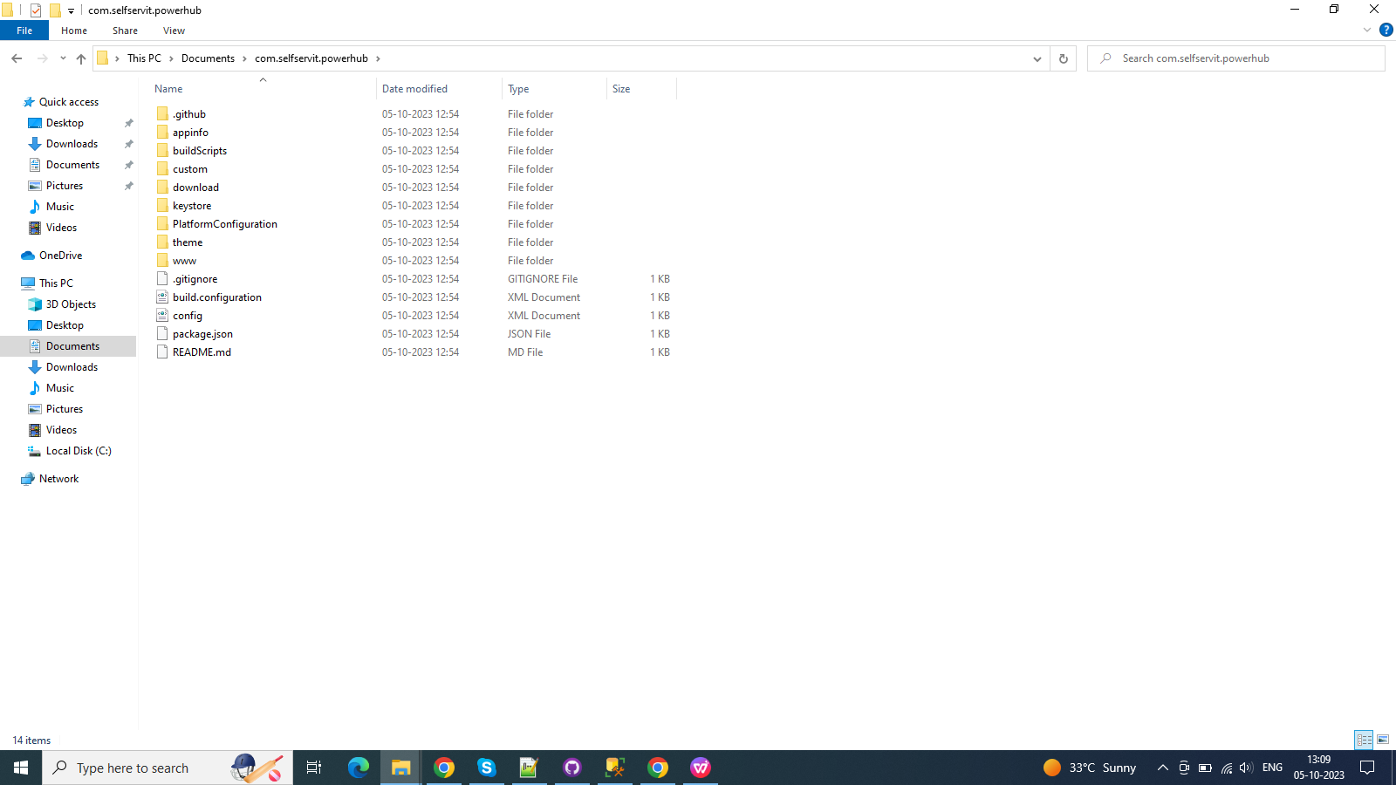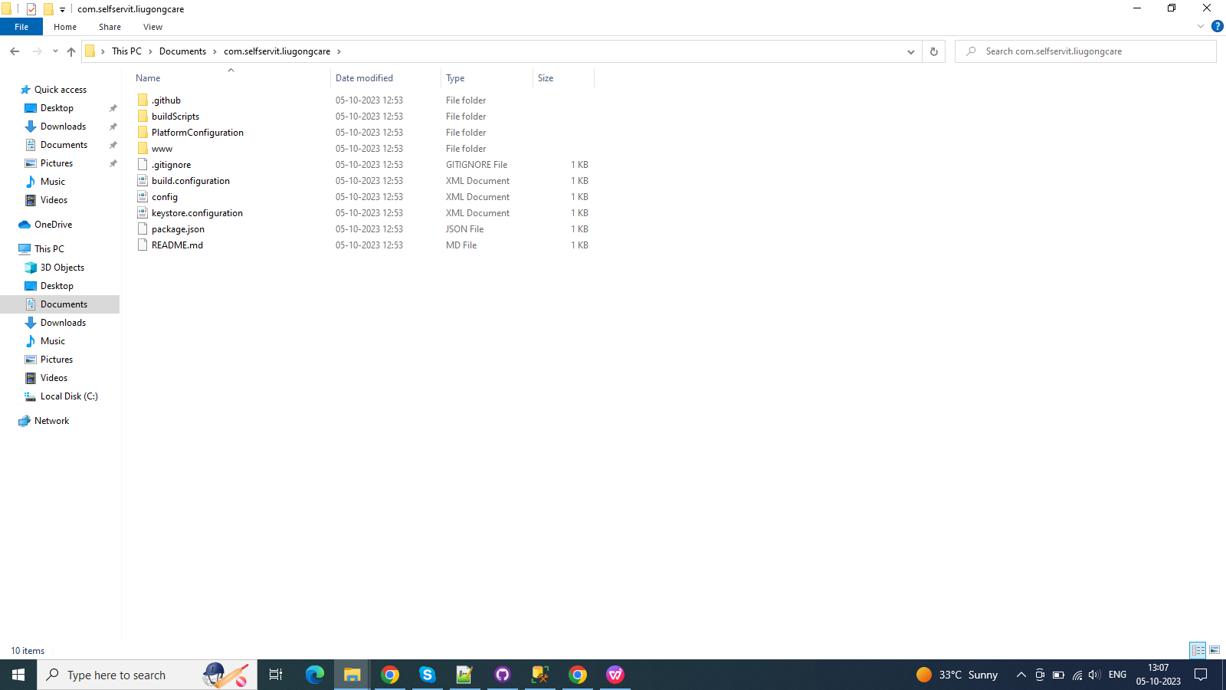

Step 1:

Need to replace the file in below mentioned path as per 1.0 app repo [ File Name : mobile-build.yml ]

Path: --> Github\com.selfservit.liugongcare\.github\workflows\mobile-build.yml

Step 2:

Need to add the file in below mentioned path as per 1.0 app repo [ File Name : update\_s3.yml ]

Path: --> Github\com.selfservit.liugongcare\.github\workflows\update\_s3.yml

Step 3:

1. Need to cut the folder in below mentioned path as per 1.0 app repo[Folder Name : android]

Path:--->Github\com.selfservit.powerhub\appinfo

1. Paste that folder in below mentioned path

Path:--->Github\com.selfservit.powerhub\PlatformConfiguration

1. Delete the folder in below mentioned path as per 1.0 app repo [Folder Name : appinfo]

Path:--->Github\com.selfservit.powerhub

Step 4:

Need to replace the file in below mentioned path as per 1.0 app repo

[ File Name : read\_build\_configuration ]

Path: --> Github\com.selfservit.liugongcare\buildScripts\read\_build\_configuration

Step 5:

Need to replace the file in below mentioned path as per 1.0 app repo

[ File Name : update\_status\_workflow ]

Path: --> Github\com.selfservit.liugongcare\buildScripts\update\_status\_workflow

Step 6:

1)Need to copy the file in below mentioned path as per 2.0 app repo[File Name : config]

Path:--->Github\com.selfservit.liugongcare\PlatformConfiguration\android\root

2)Paste that folder in below mentioned path(Need to create root folder)

Path:--->Github\com.selfservit.powerhub\PlatformConfiguration\android\root

And change the widget id, version,android-versionCode,name,description, as per your client.

image_1

Step 7:

1)Need to copy the file in below mentioned path as per 2.0 app repo[File Name : app\_settings]

Path:--->com.selfservit.liugongcare\PlatformConfiguration\common\www

2)Paste that folder in below mentioned path(Need to create common and www folder)

Path:--->Github\com.selfservit.powerhub\PlatformConfiguration\common\www

And change the default\_client\_id,app\_name, app\_root\_directory,fcm\_app\_id.

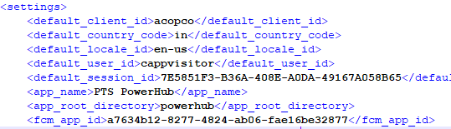

1. Delete the folder in below mentioned path as per 1.0 app repo [Folder Name : custom]

Path:--->Github\com.selfservit.powerhub\PlatformConfiguration

Step 8:

1. Delete the folder in below mentioned path as per 1.0 app repo [Folder Name : download]

Path:--->Github\com.selfservit.powerhub\PlatformConfiguration

Step 9:

1. Need to cut the folder in below mentioned path as per 1.0 app repo [Folder Name : keystore]

Path:--->Github\com.selfservit.powerhub

2)Paste that folder in below mentioned path without android folder.

Path:--->Github\com.selfservit.powerhub\PlatformConfiguration\android

Like this Path

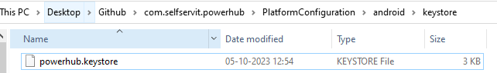

Step 10:

1)Need to cut the folder in below mentioned path as per 1.0 app repo [Folder Name : locales]

Path:--->Github\com.selfservit.powerhub\theme

2)Paste that folder in below mentioned path without android folder.

Path:--->Github\com.selfservit.powerhub\PlatformConfiguration\android\root

Step 11:

1)Need to cut the folder in below mentioned path as per 1.0 app repo [Folder Name : android]

Path:--->Github\com.selfservit.powerhub\theme\res\icon

2)Paste that folder in below mentioned path .(Need to create res and icon folder)

Path:--->Github\com.selfservit.powerhub\PlatformConfiguration\android\root\res\icon

Step 12:

1)Need to copy the folder in below mentioned path as per 2.0 app repo [Folder Name : notification]

Path:--->Github\com.selfservit.liugongcare\PlatformConfiguration\android\root\res

2)Paste that folder in below mentioned path.

Path:--->Github\com.selfservit.powerhub\PlatformConfiguration\android\root\res

Step 13:

1)Need to cut the folder in below mentioned path as per 1.0 app repo [Folder Name : android]

Path:--->Github\com.selfservit.powerhub\theme\res\screen

2)Paste that folder in below mentioned path .(Need to create screen folder)

Path:--->Github\com.selfservit.powerhub\PlatformConfiguration\android\root\res\screen

Step 14:

1)Need to create the folder in below mentioned path as per 1.0 app repo [Folder Name : screen ---> Folder Name : ios ]

Path:--->Github\com.selfservit.powerhub\PlatformConfiguration\ios\res\screen\ios

Add the image with this same name ,height,width,extension.

Name: default@2x~universal~anyany

Height:2732 px

Width:2732 px

Extension: png

Step 15:

1)Need to copy the file in below mentioned path as per 1.0 app repo [File Name : config]

Path:--->Github\com.selfservit.liugongcare\PlatformConfiguration\android\root

2)Paste that folder in below mentioned path.

Path:--->Github\com.selfservit.powerhub\PlatformConfiguration\ios\root

Step 16:

1)Need to create the file in below mentioned path as per 1.0 app repo [File Name : keystore.configuration]

Path:--->Github\com.selfservit.liugongcare

Enter below mentioned details and linearize  
  
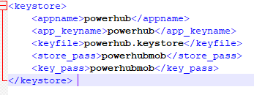

Get the key\_pass and store\_pass from mobile-build.yml

Push the file into master and build the apk.

Step 17:

Create a new cache controller file with below mentioned name and path

For Example:

Name: cache\_controller\_com.selfservit.powerhub\_acopco\_in.json

Path:GitHub\ACOPCO\_IN-LIVE\Website\fmt\msvCache

Step 18:

To Do:

1)Create new cvs files

2)Exisiting 1.0 files are need to remove and unwanted feature\_id also remove from the database.

Step 19: